**EX D**

**Sultana Disaster Museum’s**

**Economic Contributions and Economic Impacts**

**To The Economy of**

**Arkansas**

**By**

**Gregory L. Hamilton, Ph.D.**

**Senior Research Economist**

**Arkansas Economic Development Institute**

**University of Arkansas at Little Rock**

**Retired**

**January 22, 2021**

**Sultana Disaster Museum**

**Economic Consequences to the Economy of Arkansas**

The contribution analysis of 50,000 hypothetical visitors found that their spending in Crittenden County would approach $3.39 million. This would create $6.9 million in economic activity in Arkansas, adding $3.5 million to the state’s gross domestic product, generate $2.3 million of wage and salary incomes, and support 88.5 full time jobs.

I. Visitor Count by Classification



II. Anticipated Expenditures by 50,000 Visitors



III. Economic Contribution to the Arkansas Economy of 50,000  
 Visitors to Sultana Disaster Museum (Hypothetical)



The contribution analysis of 50,000 hypothetical visitors found that their spending in Crittenden County would approach $3.39 million. This would create $6.9 million in economic activity in Arkansas, adding $3.5 million to the state’s gross domestic product, generate $2.3 million of wage and salary incomes, and support 88.5 full time jobs.

IV. Classification of Visitors by Type: Summary



The existing Sultana Disaster Museum opened in April 2015. The 1,200 square foot museum is located adjacent to the Crittenden County Courthouse. The museum is open to visitors approximately 14 hours per week.

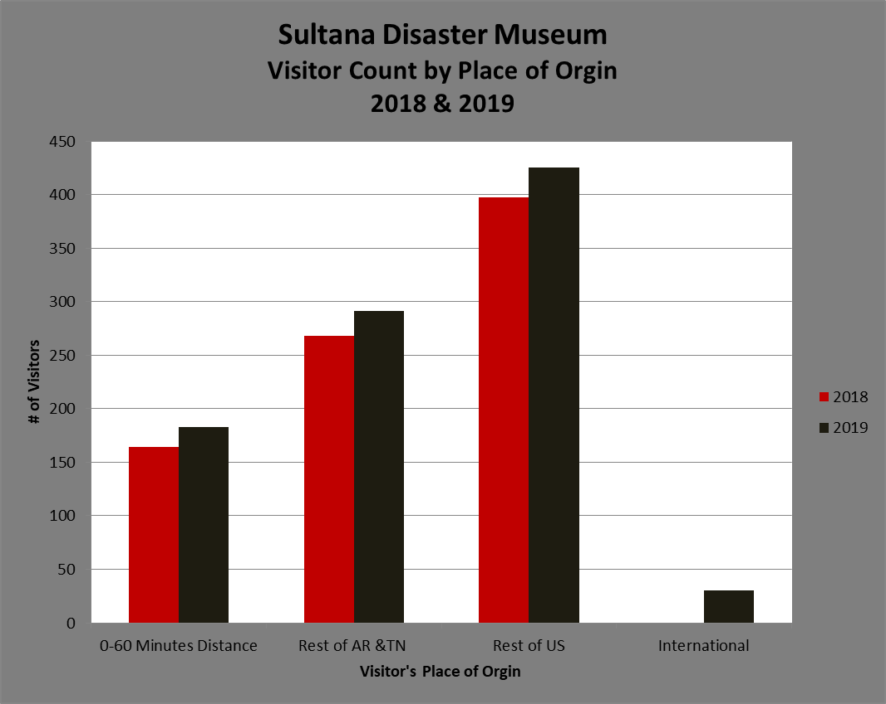

**Sultana Disaster Museum’s  
Economic Contributions to the Arkansas Economy**

**Executive Summary**

The first section of this report summarizes findings from an economic contribution study of the visitor’s spending associated with their visit to the Sultana Disaster Museum (SDM) during 2018-2019 periods. Activities include visitor’s expenditures for overnight stays, food, and shopping associated with a single day trip by local, non-local visitors, and overnight visits by domestic and international visitors. This study did not take into account the distributional effects of the activities within the study area.[1] The second section of the report analyzes the economic contributions and economic impacts associated with 50,000 hypothetical visitors to the museum.

The study utilized a multi-regional approach to gage the consequences of visitors’ expenditures. Crittenden County is the primary region where museum visitors’ expenditures are assumed to occur. The study estimates expenditures in Crittenden County by museum visitors, and then the spillover of economic activity into the rest of Arkansas. [2]

In 2019 there were 929 visitors to the Sultana Disaster Museum. Their total annual spending in Crittenden County was estimated at $59,264. A multi-region economic model was constructed to evaluate the economic contribution of this spending in the economy of Crittenden County and the rest of Arkansas’ economy.[3] This contribution analysis found that the visitors spending of $59,264 supported $182,687 of economic activity in Arkansas, added $88,655 to the state’s gross domestic product, generated $59,502 of wage and salary income, and supported 2.6 full time jobs.

In the second part of this report, the study is extended to analyze economic impacts the 50,000 hypothetical visitors to the museum. A contribution study and an economic impact study of the 50,000 hypothetical museum visitors were undertaken for comparative purposes. The chief difference between a contribution study and an impact study is that the latter excluded local spending while the former includes all visitors’ expenditures.

The contribution analysis of 50,000 hypothetical visitors found that their spending in Crittenden County would approach $3.39 million. This would create $6.9 million in economic activity in Arkansas, adding $3.5 million to the state’s gross domestic product, generate $2.3 million of wage and salary incomes, and support 88.5 full time jobs.

1. Distribution effects occur when activities associated with visits to the museum displace preexisting activities in the community. That is, there is a redistribution of economic activity from groups of activities not associated with the museum to activities associated with visiting the museum.
2. Museum visitors living less than 60 minutes from the museum are considered local visitors. However, their activities at the museum are included in the analysis. This inclusion of local visitors’ activities to those of other types of visitors to the museum means this is an economic contribution study instead of an economic impact study.
3. Implan Modeling Software and Arkansas Implan data for 2015 was used in this analysis. For further information about this software and data refer to: www.Implan.com.